Load Balancer

Steps:

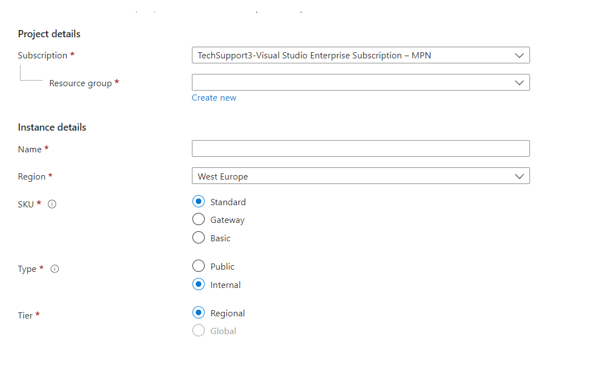

Configure the basic details like name, Subscription, Resource Group, Region, etc…